PoFormer: A Transformer-CNN hybrid model for Segmentizing Pavement Pothole

Tianjie Zhang1, Zhen Liu2, Xingyu Gu2 and Yang Lu3*

1 Department of Computer Science, Boise State University, Boise, ID, 83725

2 School of Transportation, Southeast University, Nanjing, Jiangsu Province

3 Department of Civil Engineering, Boise State University, Boise, ID, 83725

***Abstract*:**

This work introduces PoFormer, a novel Transformer-CNN hybrid model designed for the precise segmentation of pavement potholes. As a significant issue in road maintenance, the accurate detection and segmentation of potholes are critical for road safety and transportation infrastructure management. Traditional image processing techniques fall short due to the complex variations in pothole appearances and environmental conditions. PoFormer addresses these challenges by integrating the expansive representational capacity of Transformers with the precise local feature delineation capabilities of Convolutional Neural Networks (CNNs). We compiled a varied pothole dataset and conducted comprehensive experiments, evidencing that PoFormer surpasses current deep learning models including U-Net, E-Net, LRASPP, FCN and AttuNet with a mean Intersection over Union (mIoU) of 77.23% and mean Pixel Accuracy (mPA) of 84.48%. Our approach shows promise in enhancing automated road condition assessment and maintenance planning.

***Key words:***  **Transformer, pothole, image segmentation, CNN, Deep learning**

# 1. Introduction

Due to the climate changes such as heavy snow and rainstorms, there are increasing pavement defects like potholes all over the world [1]. Potholes not only pose safety hazards to road users but also contribute to accelerated pavement deterioration [2]. Accurately identifying and segmenting potholes from pavement images is crucial for effective road maintenance planning, targeted repairs, and resource allocation. Pothole detection and maintenance are becoming of paramount importance in transportation infrastructure management. Traditionally, the pothole is manually inspected by professional engineers, but it is dangerous, labor-intensive, inefficient, and time-consuming [3]. Furthermore, the manual pothole detection is subjective and very dependent on the experience and knowledge of the engineers [4]. Therefore, image processing techniques are emerged to solve this problem. For example, Buza et al. [5] presented an unsupervised vision-based method by using image processing and spectral clustering to identify and estimate the location of potholes. This method was tested on 50 images and got an accuracy of 81%. Gao et al. proposed a method by integrating grayscale and texture features to rapidly and accurately detect potholes. This method was evaluated on a customed collected dataset and got a F1 score of 98.7%. Koch et al. [6] proposed a novel method based on a shape extraction method. However, methods based on image processing techniques often struggle to handle the complex variations in pothole shape, texture, and lighting conditions.

In recent years, deep learning models have emerged as a superior alternative, offering significant advantages over traditional image processing approaches. Deep learning, powered by artificial neural networks with multiple layers, has revolutionized various fields, including transportation infrastructure detection. The ability of deep learning models to automatically learn and extract meaningful features from data enables them to surpass the limitations of handcrafted features used in traditional methods. Deep learning approaches, such as convolutional neural networks (CNNs), have demonstrated superior performance in a wide range of computer vision tasks, including object detection, defect classification, and semantic segmentation. For example, Zhang et al. [7] proposed an ECSNet in segmenting the pavement distress in a real-time task. Ukawah et al. [8] used YOLOv3 SPP to detect the asphalt pavement pothole in a self-collected dataset and the result showed a mAP of 88.93%. Ahmed et al. [9] proposed a modified VGG-16 by removing some convolutional layers and changing different dilation rates as a backbone in a Faster RNN network. The results showed that the modified VGG-16 can get a higher presision of 81.4% than VGG-16. The YOLOV5 with ResNet as its backbone got the highest mAP of 64.12%. These deep learning models leverage the hierarchical nature of neural networks to capture both low-level local features and high-level contextual information, enabling them to discern subtle patterns and distinguish between different types of distresses.

While deep learning models have yielded impressive results, recent advancements in the field of natural language processing have introduced a new paradigm: Transformers [10]. Transformers have revolutionized language modeling tasks by effectively capturing long-range dependencies and global context. This attention-based architecture has shown remarkable success in handling sequential data and has recently been extended to image analysis tasks. For example, Dosovitskiy et al. [11] proposed a Vision Transformer model (ViT) on image classification tasks and it was compared to state-of-the-art convolutional networks including ResNet and EfficientNet. The results showed that the proposed Vit performed better on datasets like ImageNet, CIFAR and Oxford-IIIT Pets. Zheng et al. [12] proposed a sequence-to-sequence structure, SEgementation TRansformer (SETR), to treat the image segmentation tasks. The transformer layer was used to encode the images through a sequence of patches. This method reached a mean Intersection over Union (mIoU) of 82.15% in the Cityscape validation dataset. These attempts showed that transformer layers are good at encoding the information from the images. Transformers have also started been utilized and applied in the pavement crack detection. Guo et al. [13] presented a Crack Transformer by integrating a swim transformer as its encoder and a Multi-Layer Perception (MLP) as its decoder to detect and segment the pavement cracks. Three crack datasets including CFD, Crack500 and CrackSC were tested and it showed the Crack Transformer can better retrieve the crack length. Han et al. [14] proposed Transformer FRTS to predict various asphalt pavement health indicators like rutting depth and surface texture depth. The inherent ability of transformer to model and extract complex relationships and capture fine-grained details makes them well-suited for analyzing spatial patterns in pavement images. However, transformer as decoders can be dependent on the specific application and the architecture of the network. In some cases, they might not be as effective as other approaches, such as CNNs, particularly when it comes to local feature extraction and pixel-level prediction tasks [15].

Therefore, in this paper, we present a novel approach, PoFormer, which is A CNN-Transformer hybrid model to leverage the power of transformers and CNNs. In this model, the input images would be sequenced first to several patches and then a transformer-based encoder would be adopted to extract the pattern and information from the patches. And then, a decoder with 4 convolutional layers is utilized to take the encoded information and spatial features and reconstruct them into an output of the same size as the original image, but with segmented regions. By adapting CNN-transformer-based architectures specifically for pothole detection, we aim to overcome the limitations of traditional CNN-only methods and further improve the accuracy and robustness of pothole segmentation. Through extensive experimentation and comparisons with traditional deep learning models, we demonstrate the effectiveness of our proposed approach in accurately identifying and delineating potholes from pavement images.

In the following sections, we outline the methodology used for pothole segmentation, present the experimental results, discuss the implications of our findings, and conclude with remarks on the potential and future directions of transformer-based approaches for pavement analysis.

# 2. Methodology

## 2.1. PoFormer

A Transformer-CNN hybrid model, PoFormer, is proposed in this work to segment the pothole from the pavement. The architecture of the proposed PoFormer is shown in Figure 1.

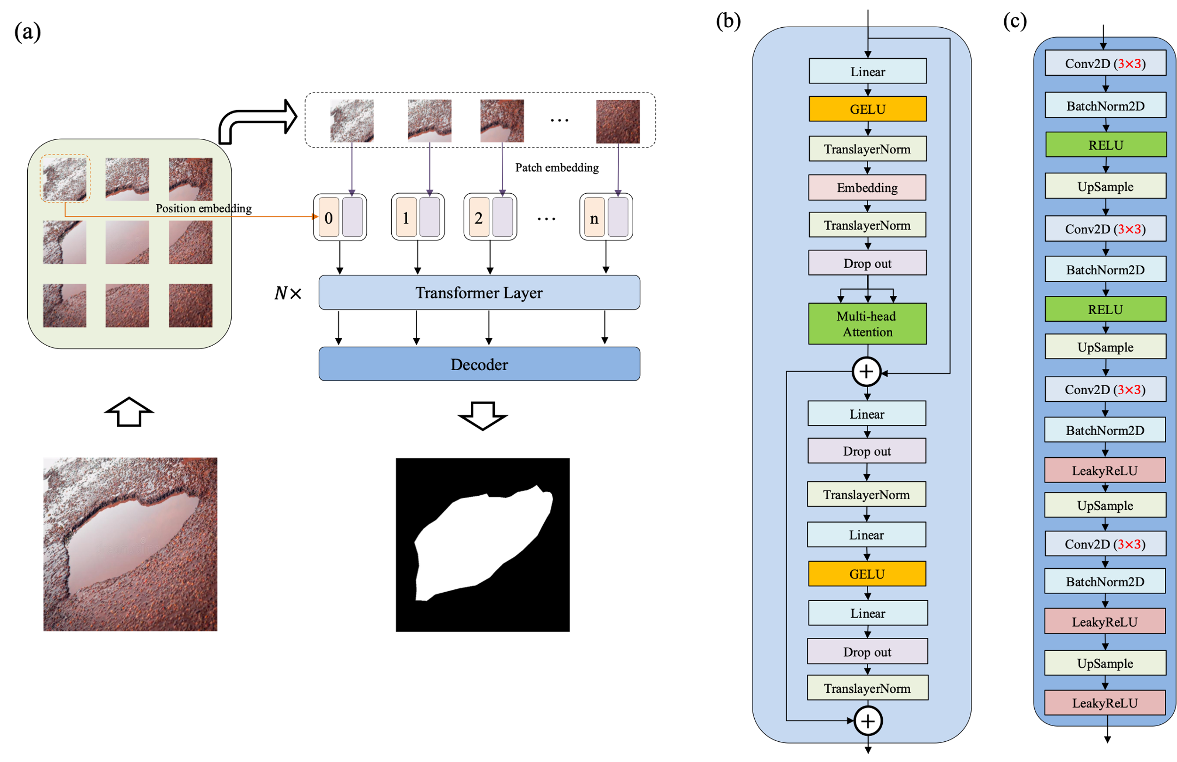

**Figure 1.** The architecture of the proposed PoFormer and its components. (a) The overall architecture of the PoFormer model. (b) The Transformer Layer and it is utilized as the encoder in this model to extract the information from the images; (c) The structure of the Decoder, which is a CNN-based structure.

As illustrated in Fig. 1, the proposed PoFormer architecture is consisting of an image sequentialization part, an encoder and a decoder. The resolution of images is different as the images are collected from different devices. Therefore, the input images would be resized to $256×256$ first before doing the image sequentialization as the model requires a fixed-size input which is crucial for batch processing. Moreover, resizing to $256×256$ helps to reduce the computational burden, making the training and inference processes more efficient. In this process, the 2D images would be transferred to one-dimensional sequences first to meet the requirement of the input to a transformer layer. The model intakes a pavement image and partitions it into *n* patches (in this case, each patch has a resolution of $32×32$, therefore, n equals to 64). These patches undergo a linear transformation to obtain flat embeddings (*E*) with an added positional encoding (*P)*, formalized as *E*(*pi*)+*P*(*i*), where *pi* is the *ith* patch and *P*(*i*) is its corresponding positional encoding. This positional information is vital in maintaining the geometric fidelity of the patches, which is paramount in accurately segmenting the intricate features of potholes.

In the encoder, the patch embeddings are processed through *N* Transformer layers. Each layer is composed of multi-head attention (*A)* and a position-wise feed-forward network (*F)*, with residual connections and layer normalization (*Norm)* applied before each sub-layer. Multi-head attention is utilized in the encoder to capture complex dependencies and handle sequential data. The multi-head attention is an extension of attention mechanisms, which allows the model to jointly attend to information from different representation subspaces at different positions. The multi-head attention is defined as:

$$A\left(H_{i}\right)=Concat({head}_{1}…,{head}_{h})W^{o}$$

$${head}_{i}=Attention({QW}_{i}^{Q},{KW}_{i}^{K},{VW}_{i}^{V})$$

where each ${head}_{i}$ is computed enabling the model to discern diverse feature interdependencies within the pavement image. Here, *Q*, *K*, and *V* stand for Query, Key, and Value, respectively. Query represents the set of vectors that are used to query the data. Keys are paired with values and are used to retrieve them. The similarity of a query with the keys determines how much attention is given to the corresponding values. Values are the actual content that you want to retrieve. The matrices $W_{i}^{Q}$, $W_{i}^{K}$ and $W_{i}^{V}$ are learned weight matrices that transform the input representations into the respective queries, keys, and values for the *ith* attention head. Each head in multi-head attention has its own set of these weight matrices, allowing the model to attend to different parts of the input in different ways simultaneously.

In our proposed PoFormer model, this attention mechanism allows the model to focus on specific parts of the pavement images that are more relevant for identifying potholes, giving it the capability to distinguish between potholes and other similar-looking features on the road by learning the most pertinent features to pay attention to for the task at hand.

Within the Transformer layers, the feed-forward network employs the GELU activation function, facilitating the model's ability to represent complex mappings. The network is formalized as:

$$F(x)=GELU(xW_{1}+b_{1})W_{2}+b_{2}$$

which introduces necessary non-linearity into the feature transformation process. *W* and *b* are the weights and bias of layers. The Gaussian Error Linear Unit (GELU) is used as the nonlinear layer in the encoder. The equation of GELU is shown below.

$GELU\left(x\right)=x×ϕ(x)$

Where $ϕ(x)$ is the cumulative distribution function for gaussian distribution.

The feed-forward network within the Transformer layers further processes these features, employing the GELU activation function to introduce non-linearity, enhancing the model's ability to represent complex functions. The inclusion of dropout and layer normalization at each step mitigates the risk of overfitting and ensures stable learning, both of which are vital for the model to generalize well across varied pavement conditions.

The decoder architecture is shown in Figure 1(c). The distribution of each layer’s inputs changes during training due to the changing parameters of the previous layer. It slows down the training procedure as the layer would require parameter initialization. Therefore, each convolutional layer in decoder is followed by a 2D Batch Normalization layer (BatchNorm2D) [16] to standardize the parameters. The operation in Batch Normalization layer is shown in Equation (1).

$y=\frac{x-E[x]}{\sqrt{Var\left[x\right]+ϵ}}×γ+β$ (1)

Where *x* is the input, y is the output, $ϵ$ is a value added to the denominator for numerical stability ( $ϵ=e^{-5}$ in this case), $γ$ and $β$ are learnable parameters during the training. E[x] and Var[x] are the mean and variance of *x*, respectively.

The decoder utilizes a succession of upsampling and convolutional operations to translate the high-level Transformer features into a segmented image. The upsampled feature map is convolved with learned filters $W_{conv}$, followed by batch normalization and activation functions, encapsulated as $ϕ(B(Conv(U*W_{conv}+b_{conv})))$. This sequence is iterated to refine the segmentation granularity progressively.

$$s= ϕ(B(Conv(U*W_{conv}+b_{conv})))$$

Where *U* stands for the upsampled feature map, *B* represents the Batch Normalization, *ϕ is the activation function, Conv* stands for the convolutional layer*, $W_{conv}$* and $b_{conv}$ are the weights and biases of each convolutional layer*.*

RELU and LeakyRELU are used as the activation function in the decoder part. The equation is shown below.

$$ReLU\left(x\right)=\left\{\begin{aligned}x, x≥0 \\ 0, otherwise\end{aligned}\right.$$

$$LeakyReLU\left(x\right)=\left\{\begin{aligned}x, x≥0 \\ ax, otherwise\end{aligned}\right.$$

Where *a* controls the angle of the negative slope, $a=e^{-2}$ in this case. LeakyReLU can improve the PoFormer fitting with increasing very little computational cost and overfitting risk.

Incorporating these academic notations and formulations bestows the model description with the rigor necessary for journal publication. The model transcends traditional segmentation approaches by combining the global contextual comprehension of the Transformer, beneficial in discerning the erratic and dispersed nature of potholes, with the CNN's adeptness at capturing localized textural details, crucial for pixel-level classification accuracy.

The proposed PoFormer is designed to enhance the performance of pavement pothole detection by enlarging the receptive fields of CNN-based networks and compensating the Transformer for the loss of local fine-grained contextual information. In the proposed architecture, we articulate a comprehensive solution for the segmentation of pavement potholes by integrating the expansive representational capacity of the Transformer with the precise local feature delineation of CNNs. This hybrid model is meticulously tailored to the segmentation of pavement potholes, utilizing the collaborative strengths of its composite architectures to foster a meticulous segmentation performance.

## 2.2 overall procedure

In our comparative analysis, five well-established models were evaluated alongside our novel CNN-Transformer hybrid model, PoFormer. The models under scrutiny are as follows: U-Net, LRASPP, FCN, E-Net and AttuNet [17]. These models were selected based on their prominence in the field and their varied architectural principles, which include:

(1) U-Net: A convolutional network renowned for its efficacy in biomedical image segmentation.

(2) LRASPP: An adaptation of the Lite Reduced Atrous Spatial Pyramid Pooling (R-ASPP) Network, employing a MobileNetV3-Large backbone, optimized for mobile devices.

(3) FCN: The Fully Convolutional Network, herein utilizing a ResNet-50 [18] backbone, known for its deep residual learning framework.

(4) E-Net: A network architecture tailored for real-time semantic segmentation, as proposed by Adam, utilizing the default hyperparameter settings.

(5) AttuNet: Specifically designed for scenarios with limited training samples, this model emphasizes attention mechanisms to refine feature representations.

To ensure statistical robustness, the original dataset underwent a randomized tripartite split, forming the basis for three independent training and testing cycles. This methodology enabled the computation of average performance metrics and associated standard deviations. The dataset was partitioned into training and testing subsets in an 80:20 ratio. Given the heterogeneous image resolutions stemming from varied acquisition sources, a standardization procedure resized all images to 256×256 pixels prior to model training. Data augmentation techniques, including random resizing and horizontal flipping, were systematically applied to the training images and their corresponding ground truths. Such augmentation generated novel inputs for the neural networks, enhancing the model's performance by leveraging the increased quantity and diversity of the dataset. Subsequent to augmentation, the training images were converted to grayscale to streamline the learning process.

Root Mean Squared Propagation (RMSProp) [19] was employed as the optimizer with a momentum of 0.9 across all models to facilitate parameter updates. The training regimen consisted of 300 iterations for each network, with an initial learning rate set at 1e-3 and a batch size of 16. Classification thresholds were standardized; an output value exceeding 0.5 denoted a pothole, while values below indicated background. The loss function utilized was BCEWithLogitsLoss [20], which amalgamates a sigmoid activation with Binary Cross Entropy loss, offering enhanced numerical stability over the conventional approach of a standalone Sigmoid activation followed by BCELoss [17].

The implementation of the data augmentation methods and CNN models was performed in Python and executed on a system equipped with Windows 10, an Intel(R) Core(TM) i9-10900X CPU, an NVIDIA RTX A4000 GPU with 16 GB of memory, and 64 GB of system RAM.

## 2.3 Evaluation Metrics

To assess the performance of the segmentation models, we employed Mean Intersection over Union (mIoU) and Mean Pixel Accuracy (mPA) as the principal metrics. The IoU metric quantifies the percentage overlap between the model's predicted pothole segmentation and the ground truth. It is calculated for each class separately within segmentation tasks according to the following equation:

$$IoU=\frac{A_{o}}{A_{u}}$$

Where $A_{o}$ denotes the area of overlap between the predicted segmentation and the ground truth, $A_{u}$ stands for the combined area of the predicted and ground truth segmentations.

The mIoU represents the mean of IoU scores across all classes. It is determined by averaging the IoU for each class, as expressed in the equation:

$$mIoU=\frac{1}{n}\sum_{i=1}^{n}{{IoU}_{i}}$$

Here, *n* is the number of classes within the dataset, which in our case is two (pothole and non-pothole areas).

Pixel Accuracy (PA) is another straightforward metric, defined as the ratio of correctly classified pixels to the total pixel count. For an individual class, PA is given by:

$$PA= \frac{P}{T}$$

where *T* is the total pixel count that should be classified within that class, and *P* is the number of pixels accurately classified as belonging to that class.

mPA is the average of the PA values across all classes, calculated using the formula:

$$mPA= \frac{1}{n}\sum_{i}^{n}{{PA}_{i}}$$

The utilization of mIoU and mAP offers a balanced evaluation of the models, considering both the precision of the segmentation and the accuracy of the pixel classification, thereby providing a comprehensive view of the model's segmentation performance.

# 3. Results

## 3.1 Benchmark

Prior studies have often developed bespoke methods tailored to small, proprietary datasets to validate their accuracy. This practice, however, significantly hampers the comparability of various approaches. Consequently, we have established a comprehensive open-source database to serve as an empirical foundation for advancing research in pothole detection and segmentation. The dataset comprises 1183 manually annotated RGB images of potholes, ensuring a high level of detail and accuracy in the annotations. Some representative images and its corresponding segmentations are shown in Figure 2.

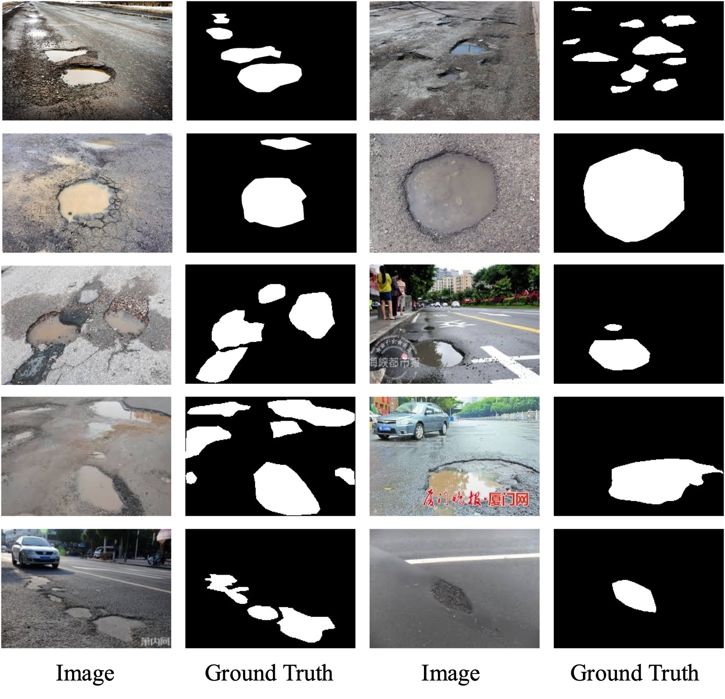

Figure 2. Some representative samples in the proposed dataset.

Figure 2 illustrates a curated selection of images from our comprehensive dataset, which is designed to reflect a range of real-world conditions affecting pothole visibility and detection. Accompanying each image is its respective binary segmentation mask, delineating the pothole boundaries for computer vision applications. This collection showcases various pothole scenarios, including different sizes, shapes, and severities, as well as a variety of environmental conditions such as wet and dry pavements. The images originate from a dual-sourced methodology: the first set is derived from an extensive internet search to ensure diversity, and the second set consists of photographs taken manually by the research team, aiming to capture the nuanced details of potholes in local environments. This integrative approach ensures the dataset's robustness and its utility in developing and benchmarking pothole detection algorithms. Researchers and practitioners can access the full dataset, which contains high-resolution images and precise annotations, on the GitHub repository at https://github.com/tjboise/PoFormer. The availability of this dataset aims to foster innovation and standardize benchmarks in the domain of automated pothole detection and segmentation.

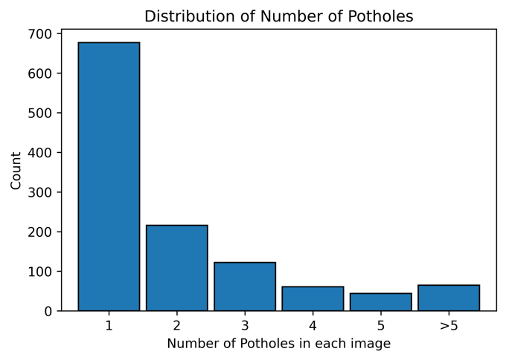

Figure 3. Distribution of Pothole Frequencies per Image in the Dataset.

Figure 3 provides a quantitative analysis of the pothole frequencies as observed in the dataset. It delineates the count of potholes per image, offering insights into the prevalence and clustering of potholes within individual images. Specifically, the dataset comprises 677 images each depicting a single pothole, highlighting the most common occurrence in urban settings. In contrast, a significant number of images, amounting to 506, feature more than two potholes. A smaller subset of 65 images captures scenarios with over five potholes, illustrating more severe roadway degradation. This variation in pothole distribution is reflective of actual road conditions and is critical for ensuring the diversity needed for training computer vision models. The wide range of pothole manifestations within the dataset is intended to bolster the generalization capabilities and enhance the robustness of pothole detection models when applied to real-world scenarios.

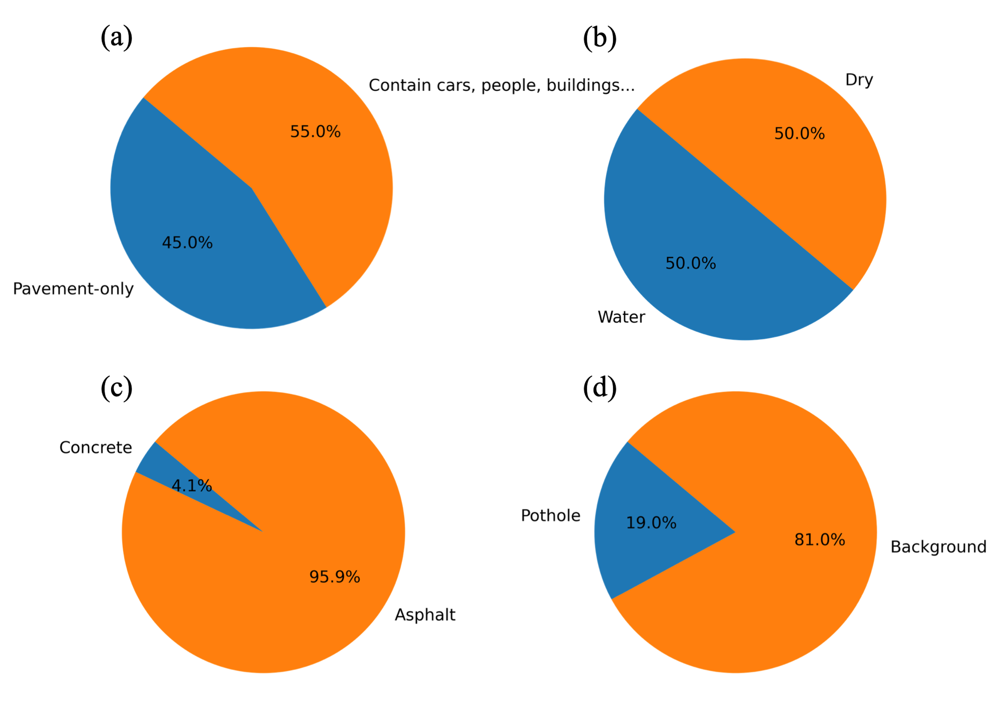

Figure 4. Compositional Statistics of the Pothole Detection Dataset.

Figure 4 provides a comprehensive breakdown of the dataset's composition in terms of various environmental and contextual factors relevant to pothole detection. Figure 4(a) contrasts the proportion of images featuring solely pavement backgrounds (45%) with those depicting additional elements such as vehicles, pedestrians, buildings, and vegetation (55%), underscoring the complexity the model must navigate. The presence of water in potholes, a factor influencing the performance of detection algorithms, is accounted for in Figure 4(b), which equally splits the dataset between wet (50%) and dry (50%) pavement conditions, thereby enhancing the robustness of the resulting model. Figure 4(c) differentiates between concrete (4.1%) and asphalt (95.9%) pavements, with the latter being more predominant, mirroring the common road compositions encountered in urban environments. Lastly, Figure 4(d) quantifies the pothole to non-pothole pixel ratio within the images, revealing that potholes account for an average of 19% of the image area, a statistic that further informs the severity of road damage represented in the dataset.

## 3.2 Model performance

Figure 5 presents the epoch-wise progression of the loss function for each evaluated model throughout the training phase. It is observed that PoFormer consistently maintains the lowest loss, indicative of superior model convergence and learning efficacy. In contrast, the FCN model exhibits the highest loss values across epochs, which correlates with its suboptimal performance on the test data. This inverse relationship between training loss and test performance suggests that PoFormer is better suited for capturing the nuances of the task, whereas the FCN model's learning trajectory indicates potential challenges in generalization or model capacity.

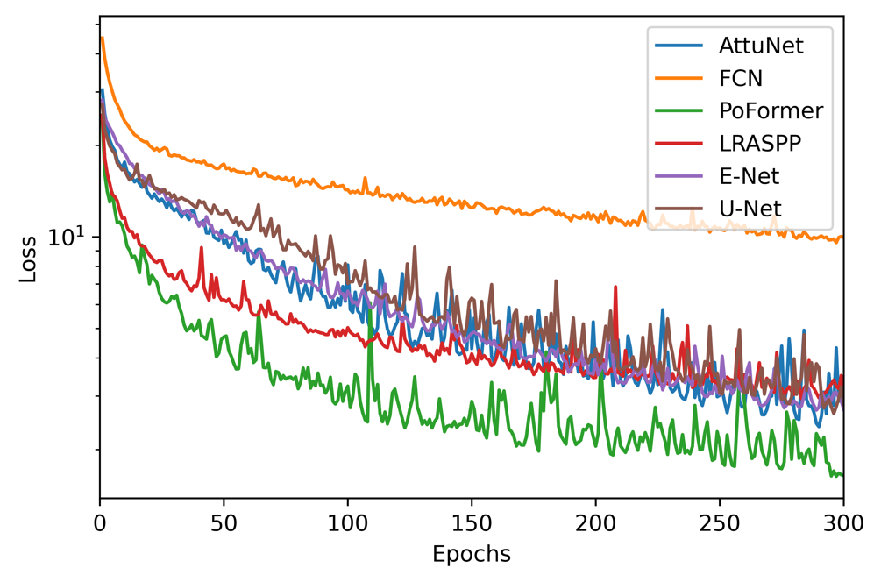

Figure 5. Epoch-wise Loss Trajectories for Evaluated Models.

Table 1 presents a comparative analysis of various models, including the proposed PoFormer model, based on their performance metrics. The FPS column indicates the speed of the model's inference, with higher numbers signifying faster performance. The '#Parameters' column lists the complexity of each model in terms of the total number of parameters, with lower numbers indicating a more lightweight model.

Table 1 delineates a detailed comparative assessment of the evaluated models, including the proposed PoFormer, across key performance metrics. The 'FPS' (Frames Per Second) column quantifies each model's inference velocity, wherein higher values are indicative of greater computational efficiency during real-time processing. Concurrently, the '#Parameters' column reflects the model complexity, with a lesser count denoting a more streamlined architectural design.

Table 1. Comparative Performance Metrics of Evaluated Models.

|  |  |  |  |  |  |
| --- | --- | --- | --- | --- | --- |
| Model | FPS | #Parameters | Precision | Recall | F1-score |
| FCN | 25.37 | 32940481 | 79.25 | 60.80 | 68.79 |
| E-Net | 24.34 | 355538 | 83.77 | 66.87 | 74.31 |
| LRASPP | 30.90 | 3217850 | 86.10 | 71.91 | 78.36 |
| U-Net | 30.51 | 13394177 | **86.78** | 59.68 | 70.71 |
| AttuNet | 23.54 | 34877421 | 86.09 | 68.47 | 76.27 |
| PoFormer | 20.47 | 45921665 | 85.92 | **72.20** | **78.43** |

The data reveals that, while the U-Net model achieves the pinnacle of precision, it falls short in terms of recall, culminating in a diminished F1 score. Contrariwise, the PoFormer model excels, registering the most substantial recall and F1 scores among its counterparts. This suggests that PoFormer balances the trade-off between precision and recall more effectively, potentially rendering it a more robust solution for the given application.

Table 1 indicates that while PoFormer has a higher computational complexity, it competes closely with LRASPP in terms of mIoU and surpasses all other models in mPA, suggesting that the trade-off in model size and speed may be justified by its accuracy in segmentation tasks.

The models are evaluated on mIoU, and mPA. Each model was evaluated three times on a randomly splitted dataset. The average value and the standard deviation are calculated as shown in Figure 6.

The graph in Figure 6 presents the performance of various models evaluated in terms of mIoU and mPA. Each model underwent a series of three evaluations on distinct subsets derived from a randomly partitioned dataset, from which the mean and standard deviation of their performance metrics were calculated.

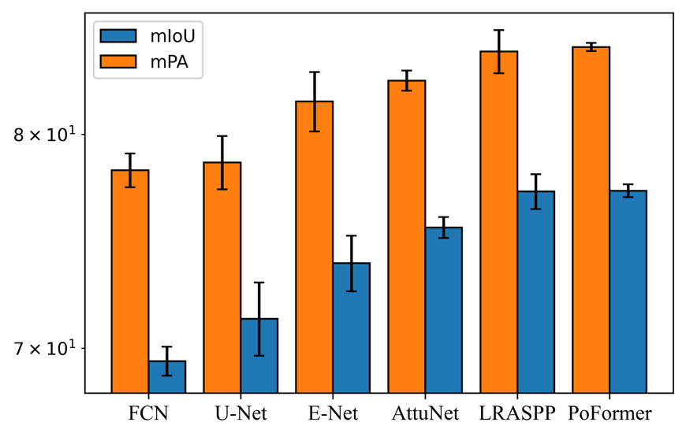

Figure 6. Comparative Analysis of mIoU and mPA Metrics Across Models.

The FCN registered an average mIoU of 69.44 (±0.63) and an average mPA of 78.23 (±0.83), reflecting consistent but not optimal performance. The LRASPP model outperformed its counterparts, achieving an mIoU of 77.19 and an mPA of 84.24. This model also demonstrated superior computational efficiency, evidenced by the highest FPS rate of 30.90. Our proposed model, PoFormer, showed commendable accuracy, achieving an mIoU of 77.23 and an mPA of 84.48. it performs highest recorded mIoU and mPA among the evaluated models. With minimal variance in its predictions, PoFormer's performance is indicative of its robustness and precision in segmenting potholes within the dataset.

Some visualization of detection results of these deep learning-based models is shown in Figure 7 to show their segmentation performance.

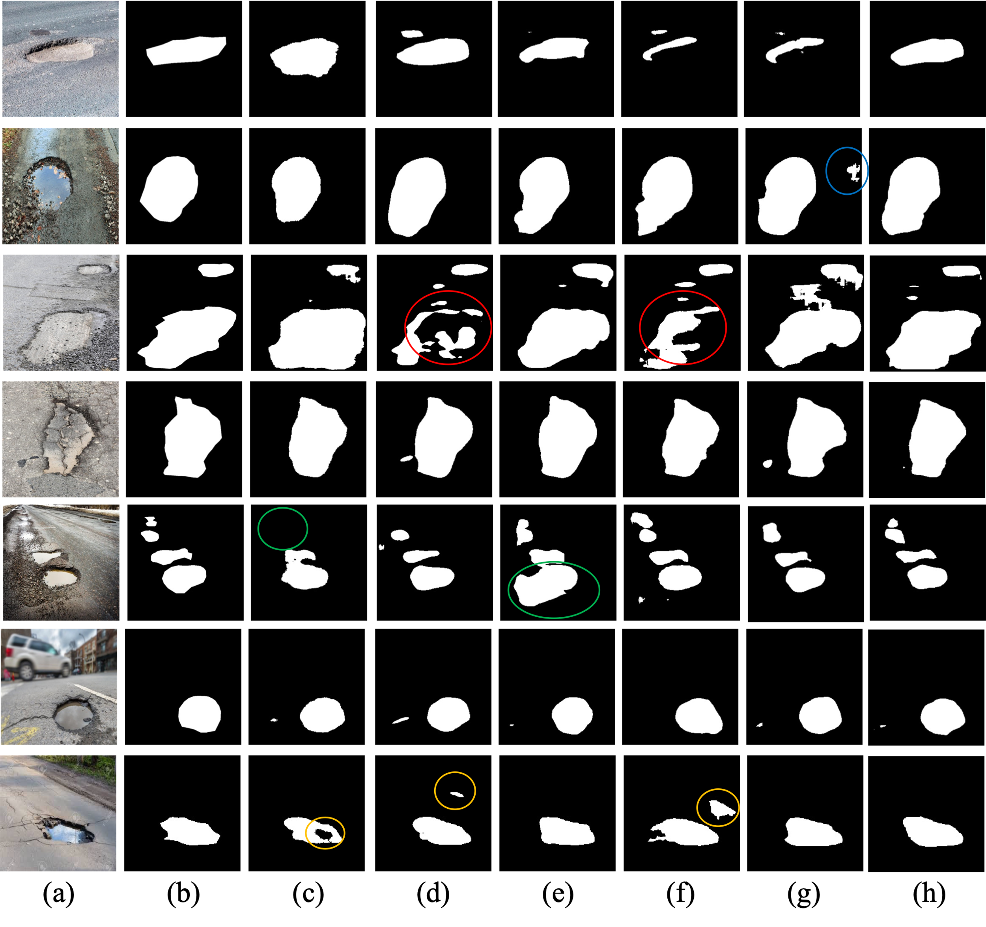

**Figure 7.** The visualization of detection results of compared methods: (a) Original Image; (b) Ground Truth; (c) E-Net; (d) FCN; (e) LRASPP; (f) U-Net; (g) AttuNet; (h) PoFormer.

As we can see from Figure 7, it is discernible that the FCN and U-Net models exhibit discontinuities in segmentation, particularly highlighted within the regions enclosed by red circles. These areas demonstrate a lack of alignment with the ground truth, with the models producing fragmented segmentations. The green-circled instances in the fifth row bring to light the limitations of E-Net, which omits smaller potholes, and LRASPP, which tends to erroneously classify background pixels as potholes. The segments marked by yellow circles accentuate the propensity of both FCN and U-Net to engage in over-segmentation, misclassifying background areas as potholes, whereas E-Net tends towards under-segmentation, failing to encapsulate entire pothole regions.

The visual comparison robustly illustrates the divergence in model performance, with PoFormer’s segmented outputs demonstrating remarkable concordance with the ground truth. This fidelity suggests that PoFormer outstrips the comparative models in discerning the nuanced features of potholes, thereby substantiating its superior segmentation capabilities.

# 4. Conclusion

The research presented in this paper successfully proposes and validates PoFormer, a Transformer-CNN hybrid model, as an effective tool for segmentizing pavement potholes. The model's encoder-decoder structure leverages the strengths of both architectures, offering improved accuracy in the segmentation of potholes compared to traditional deep learning models. Our experimental results confirm that PoFormer achieves superior performance metrics, with a mean IoU of 77.23% and a mean Pixel Accuracy of 84.48%. These results substantiate the model's capability to accurately segment potholes, which is essential for the development of intelligent transportation systems and infrastructure maintenance. Future research directions include optimizing the model's computational efficiency and extending its application to other pavement distress types such as cracks and various defects. The findings of this study provide a foundation for the advancement of automated pavement condition assessment techniques, with the potential to significantly impact the field of transportation infrastructure management. The contributions of this research extend beyond pothole segmentation. The integration of transformers into pavement analysis tasks opens up new avenues for advanced computer vision techniques in transportation infrastructure management. The insights gained from this study can inform future developments in automated road condition assessment, maintenance planning, and resource optimization. It is the first attempt to conduct a pavement distress segmentation using a Transformer-CNN hybrid network. It shows that transformer-based encoder can effectively and accurately extract the information from the distress on the pavement.

References

[1] T. Kim and S.-K. Ryu, "Review and analysis of pothole detection methods," *Journal of Emerging Trends in Computing and Information Sciences,* vol. 5, no. 8, pp. 603-608, 2014.

[2] A. Dhiman and R. Klette, "Pothole detection using computer vision and learning," *IEEE Transactions on Intelligent Transportation Systems,* vol. 21, no. 8, pp. 3536-3550, 2019.

[3] R. Fan, H. Wang, M. J. Bocus, and M. Liu, "We learn better road pothole detection: from attention aggregation to adversarial domain adaptation," in *Computer Vision–ECCV 2020 Workshops: Glasgow, UK, August 23–28, 2020, Proceedings, Part IV 16*, 2020: Springer, pp. 285-300.

[4] S. Mathavan, K. Kamal, and M. Rahman, "A review of three-dimensional imaging technologies for pavement distress detection and measurements," *IEEE Transactions on Intelligent Transportation Systems,* vol. 16, no. 5, pp. 2353-2362, 2015.

[5] E. Buza, S. Omanovic, and A. Huseinovic, "Pothole detection with image processing and spectral clustering," in *Proceedings of the 2nd International Conference on Information Technology and Computer Networks*, 2013, vol. 810, p. 4853.

[6] C. Koch and I. Brilakis, "Pothole detection in asphalt pavement images," *Advanced engineering informatics,* vol. 25, no. 3, pp. 507-515, 2011.

[7] T. Zhang, D. Wang, and Y. Lu, "ECSNet: An Accelerated Real-Time Image Segmentation CNN Architecture for Pavement Crack Detection," *IEEE Transactions on Intelligent Transportation Systems,* 2023.

[8] E. N. Ukhwah, E. M. Yuniarno, and Y. K. Suprapto, "Asphalt pavement pothole detection using deep learning method based on YOLO neural network," in *2019 International Seminar on Intelligent Technology and Its Applications (ISITIA)*, 2019: IEEE, pp. 35-40.

[9] K. R. Ahmed, "Smart pothole detection using deep learning based on dilated convolution," *Sensors,* vol. 21, no. 24, p. 8406, 2021.

[10] A. Vaswani *et al.*, "Attention is all you need," *Advances in neural information processing systems,* vol. 30, 2017.

[11] A. Dosovitskiy *et al.*, "An image is worth 16x16 words: Transformers for image recognition at scale," *arXiv preprint arXiv:2010.11929,* 2020.

[12] S. Zheng *et al.*, "Rethinking semantic segmentation from a sequence-to-sequence perspective with transformers," in *Proceedings of the IEEE/CVF conference on computer vision and pattern recognition*, 2021, pp. 6881-6890.

[13] F. Guo, Y. Qian, J. Liu, and H. Yu, "Pavement crack detection based on transformer network," *Automation in Construction,* vol. 145, p. 104646, 2023.

[14] C. Han *et al.*, "Asphalt Pavement Health Prediction Based on Improved Transformer Network," *IEEE Transactions on Intelligent Transportation Systems,* vol. 24, no. 4, pp. 4482-4493, 2022.

[15] J. Xu, W. Shi, P. Gao, Z. Wang, and Q. Li, "UperFormer: A Multi-scale Transformer-based Decoder for Semantic Segmentation," *arXiv preprint arXiv:2211.13928,* 2022.

[16] S. Ioffe and C. Szegedy, "Batch normalization: Accelerating deep network training by reducing internal covariate shift," in *International conference on machine learning*, 2015: pmlr, pp. 448-456.

[17] T. Zhang, D. Wang, A. Mullins, and Y. Lu, "Integrated APC-GAN and AttuNet Framework for Automated Pavement Crack Pixel-Level Segmentation: A New Solution to Small Training Datasets," *IEEE Transactions on Intelligent Transportation Systems,* 2023.

[18] K. He, X. Zhang, S. Ren, and J. Sun, "Deep residual learning for image recognition," in *Proceedings of the IEEE conference on computer vision and pattern recognition*, 2016, pp. 770-778.

[19] T. Kurbiel and S. Khaleghian, "Training of deep neural networks based on distance measures using RMSProp," *arXiv preprint arXiv:1708.01911,* 2017.

[20] E. Salcedo, M. Jaber, and J. R. Carrión, "A Novel Road Maintenance Prioritisation System Based on Computer Vision and Crowdsourced Reporting," *Journal of Sensor and Actuator Networks,* vol. 11, no. 1, p. 15, 2022.